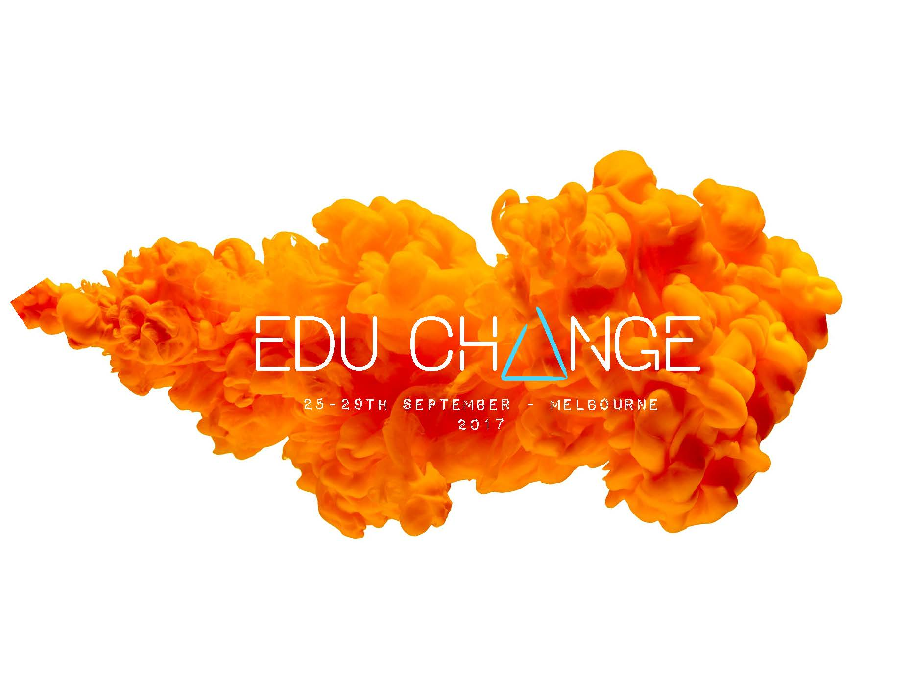
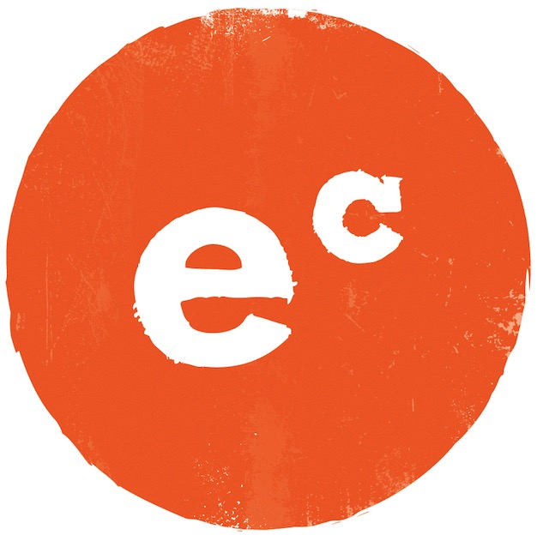
In 2017 we are going big.

For one week in September 2017, educators are gathering from all over Australia to meet, teach and inspire each other. With events run across Melbourne by EC (and some of our friends), tailored for different audiences including STEM, new teachers, education leaders and the EC tribe, this is THE education event of 2017. Expect the vibe of a regular EC event, and then dial it up a few notches. This is going to be epic.
Your name:

Your email:

Your role and your school or organisation:

What specific events or speakers would you love to see during EduChange Week (ie New Teachers, STEM, Indigenous Leaders, Australian teachers on stage, big names from overseas):
Submit
powered by

